EVALUATION OF THE WEBSITE ‘AISYIYAH SURAKARTA of UNIVERSITY
PERFORMANCE BASED ON SEARCH ENGINE OPTIMIZATION
USING AUTOMATED SOFTWARE TESTING GTMetrix

1st Aisyah Mutia Dawis, M.Kom., 2st Ismail Setiawan, M.Kom.
‘Aisyiyah Surakarta of University
Jl. Ki Hajar Dewantara No.10 Kentingan, Jebres, Surakarta
1st aisyahmd@aiska-university.ac.id, 2st ismail@aiska.university.ac.id

Abstract—Each college would have definitely have a website, because in the world of Education, the website is very important in addition to as one of the supporting facilities for the needs of the information, the website also as a media promotion for each college. Therefore the performance of the website on higher education should be the most important thing due to one important role of a website in the support activities in a higher education. ’Aisyiyah Surakarta of University is one of the new university after previously named Stikes Aisyiyah Surakarta, therefore, the evaluation of the quality of the website conducted to determine the quality of the website using GTMetrix. The purpose of this study is to determine the performance of the website ‘Aisyiyah Surakarta of University as well as provide recommendations for improvement for the management of the website. Based on the test results obtained by the website located at grade E.
Keywords : SEO (Search Engine Optimization), Website, GTMetrix

- INTRODUCTION
In the current era, the changing world of technology is considered to be the faster, one of them namely in the part of information technology, with the development of information technology little by little but will definitely change the information delivery media. One of them is by wearing the medium of the internet via the website.
The Website is a source of data on the internet that is already widely used. The Website is a collection of pages that can display some information in the form of text, images, sounds and video. These Data form a series of and are interrelated are connected using hyperlinks. In the academic world, a website is often used as a means of publication of the article, journal, learning, profile, activities, learning and promotion conducted by academic Institutions such (Shofyan,2010)
A variety of previous research that produces the strategies in this SEO has been developed by several Universities. Not a few of them using SEO services to boost the University's website. In situations of competition in the utilization of technology such as this is very important due to the presence of the utilization of technology, the College gained the market share of search in the Search Engines. (Hadiana, 2018).
In the world of Education, the website is very important because as one of the supporting facilities of information and communication. The quality of the website within the world of Education will affect the quality of service the deployment of an information which is likely to impact on the satisfaction level of the academic community and the public when accessing information.
Website of the University is one of the main foundations of media information. In addition, the website also is an important media to market an object easily because the information in the form of a website easy to served and easily accessible by the public. One way to increase website visitors is by using search engines, and the Technique is called SEO (Search Engine Optimization).(Riyanto,2018).
The application of SEO is considered able to improve the ranking of website on search engines so that the impact of the website will be up and can also affect the rating assessment webometric.info. The development of Social media is growing very rapidly proven Indonesia ranks to 4 users facebook terbear in the world (Rmg, 2013).
Therefore, the performance of the website at ‘Aisyiyah Surakarta of University should be an important concern due to one important role of the website in support of the activities of the college or university. There is some reference that can be used as a material consideration in determining both the poor quality of the website, including the layout or design consistent, the speed of access, writing or text that is easy to read as well as the quality of the sound or video presented in the website.
‘Aisyiyah Surakarta of University already have a website which explains the profile of the campus, the activities of the students and lecturers as well as to promote the University by displaying the accomplishments already achieved by the students and lecturers. Due to the website universitas ‘aisyiyah Surakarta as one of the media to the publication of information, then to know the quality of the website such research needs to be done in order to measure and determine the quality of the performance of the website ‘aisyiyah Surakarta of university
Quality evaluation of the website was done to determine the quality of a website based on the YSlow and PageSpeed with the use of automated software testing GTMetrix. From the analysis carried out using automated software testing GTMetrix generates some recommendations to improve the quality of the management of the website.

- RESEARCH METHODS
The research that the author did this refers to the research that has been there earlier still something to do on the current research. Previous research conducted by Santoso (2010) by using the method of SEO (Search Engine Optimization) Image to improve the SERP (Search Engine Result Page). Research
such is part of the SEO techniques On Page i.e. how the optimization of the image on the website. Deficiency
of this research is only limited to the image without performing optimization on the content-any other content.
Then there are other studies with the methods of SEO (Search Engine Optimization) Off the Page on the website University of Ahmad Dahlan, which is carried out by the Marselina (2012), which discusses the process to increase website Universitas Ahmad Dahlan with the method of Off-Page SEO in order to facilitate in getting the index, baclink, and pagerank. But on his research there are some shortcomings which the process of the increase could not be seen clearly, due to only rely on the process of Off-Page SEO is simple, and in the study the result up and down on index and backlink is not because the process of SEO done, as well as less prove the existence of improvement such as pagerank that really increases if backlinks increased.
This This research method using the approach of Automated Usability Testing Tools that are used to test the quality and performance of the website ‘Aisyiyah Surakarta of University Performance is assessed based on the Performance, No of Requests, Speed, Load Time and Page Size. To find out if desired by the search engines, of course we need the tools to conduct an assessment of the website. The researchers chose GTMetrik to conduct an assessment of the ‘Aisyiyah Surakarta of University to better suit the search engines.
GTMetrix is a tool automated software testing as a tool to measure the performance of the website. This Tools uses Google Page Speed and Yahoo YSlow as a machine for analysis, these tools are used to determine the performance of a website based on the parameters that are already available such as the page speed grade, grade YSlow page load time, page size and number of HTTP requests. These test results will be displayed with the recommendation that must be done by the makers of the website ‘Aisyiyah Surakarta of University. Based on the information detailed on the website GTMetrix, displayed in the form of a grade with the score view in the form of numbers as well as the value marked with the letters A, B, C, D, E and F qualitatively, while for the assessment score for the quantitative form of numbers.
If the score indicates A Grade on GTMetrix, then the speed of loading the website has been very good, While if the score indicates the Grade reaches F then we have to improve, of the theme, the selection of image quality, tilisan, CSS etc.
After the researchers measure the performance of the website using GTMetrix, then the researcher will provide recommendations and a brief description of what should be done to increase Grade using GTMetrix.
Data collection was conducted in October 2021 by using an internet connection with a download speed of 2.79 Mbps and Upload is 10Mbps. Measurement of the speed of konseksi carried out using applications that speedtest.net. The results of measurements of the speed of the internet used as a reference that the testing process can run well.

- RESULT AND ANALYSIS
In this chapter will be diuraisan for a detailed discussion of the application of SEO(search engine optimization) using GTMetrix.

3.1. The Preparation Phase

1. Preparation tools Support SEO
This process is done by means of some supporters of SEO. On the parameters of the SEO done with the stages beginning with how to set up SEO tools that are needed by the researchers.
2. Number Of Searches
Keyword search use the tool Google Key Keyword Planner to determine the amount of seeker on the search engine.
3. Website 'Aisyiyah Surakarta of University
Set up the address or the page portal that will be used to conduct research.

3.2. Stages of Implementation

Testing in this research is done by entering the address of the portal in the address bar on the homepage GTMetrix. Figure 1 shows that the testing website of the ‘Aisyiyah Surakarta of University done using GTMetrix.
Researchers began testing the evaluation of the website ‘aisyiyah Surakarta of university using GTMetrix. Then, we will see that GTMetrix do the analysis through the page or the address of the portal are already written in the address bar.

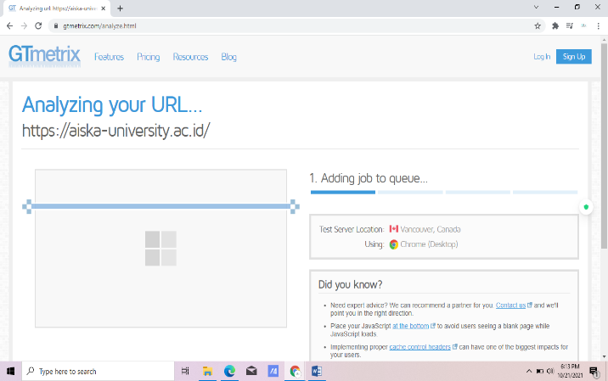

Figure 1. Examples of Testing with GTMetrix

Figure 1 shows how to GTMetrix analysis of the website ‘Aisyiyah Surakarta of University. This process takes approximately 60 seconds. GTMetrix uses a scoring system and to give you a warning apabile an error occurred on the website. Sometimes they can look confusing and you need time to understand each error message given by GTMetrix.

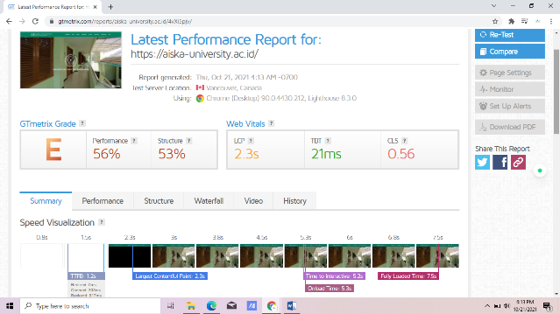
Figure 2. GTMetrix shows the results of the performance of the website

From the test results using GTMetrix , the researchers were able to get the results as shown in Table 1. In Table 1, described how the presentation obtained on the column performanced score and page detail, each of these categories there is a section in more detail, namely the PageSpeed, YSlow, Page Load, Total Page Size and Request Count.

Table 1. The Results Of The Testing GTMetrix
Performance Score |  | Page Detail
PageSpeed | YSlow | Page Load | Total Page Size | Request Count
E (56%) | E (53%) | 2.3s | 21ms | 0.56

Table 1 presents the data that the performance of the website ‘Aisyiyah Surakarta of University at the level of E on PageSpeed with a percentage of 56% and in YSlow is at the level of E with a percentage of 53%. The access speed of the website ‘Aisyiyah Surakarta of University amounting to 2.3 seconds.
Based on testing performance metrics performance made using the performance data of the lighthouse is known that the charge of the network is found to be much greater than that recommended that 1.8 seconds while the recommended by 0.9 seconds, it can overload the user or the user being open website ‘Aisyiyah Surakarta of University.
The recommendations suggested improvements can be seen in Table 2.

Table 2. Recommendations for improvement
No | Recommendations for improvement
1 | Serve scaled images
2 | Optimize images
3 | Minify javascript
4 | Inline small javascript
5 | Enable gzip compression
6 | Interactive time website

The recommendations presented in Table 2 constitute a recommendation priorities for improving the quality of the performance of the website ‘Aisyiyah Surakarta of University. From the results of the recommendations of the website obtained : (1) Serve scaled images, the website is recommended to be able to do image optimization as needed to perform image optimization can use the app paint, gimp, photoshop etc; (2) Optimize the size, the website is recommended to follow the size recommended. (3) Minify javascript, when the website uses a lot of javascript likely the website will load all the javascript there. With the minify javasacript, it is expected to reduce the number of requests to the server. (4) Inline small javascript, these recommendations can save the overhead of making multiple small file. An alternative to inline javascript is by way of doing combination with an external javascript file. (5) Enable gzip compression, the website is recommended to be able to enable gzip compression. This action is done to minimize some of the file size. (6) Interactive time website, is recommended because during the test using the performance data of the lighthouse showed the website is much longer that the normal of the website indicates the 2.5 s but the website Universitas ‘Aisyiyah Surakarta shows the 5.2 s.

VI. CONCLUSION
Based on the results of research on the website 'Aisyiyah Surakarta of University, it can be concluded as the following:
- This The results of testing the research evaluation of the performance of the website ‘Aisyiyah Surakarta of University can be concluded that the Performance Score with Page Speed in level E (56%) and Yslow at the level of E (53%). Detail Page with details in Table 1.
- On the website of ‘Aisyiyah Surakarta of University has been showing good information, in a timely and accurate enough and able to meet the desire of the University and the user. The results of measurements economical, this website gives the menu to the user about the information the University as well as facilities owned by the University. But this website has some of the menu there are still empty content.

THANK-YOU NOTE

The author would like to thank you for the addressed all the parties involved in the preparation of this study. Furthermore, to the Institute of Business and Technology – AAS Indonesia and the International Journal of Systems & Computer Information systems (ICIS), which have facilitated the author in the publication of this study.

REFERENCES
- A. ID hadiana, “Model Search Engine Optimization Bagi Usaha Mikro Kecil dan Menengah (UMKM) di Bandung Barat,” Jumanji, vol 02, no. 01, pp. 31 – 38, 2018
- A. Clarke, Learn Search Engine Optimization with smart Internet marketing strategies. Simple Effectiveness Publishing, 2018.
- A. Sharma, “Trends in Internet-based business-tobusiness marketing,” Industrial Marketing Management, vol. 31, no. 2, pp. 77–84, 2002.
- Alam, Syamsul. 2015. Manfaat Seach Engine Optimization. http://www.Syamsulalam.net. Diakses pada tanggal 17 April 2017.
- A. Riyanto, “Analisis Dan Penerapan Search engine Optimization Pada Website Menggunakan Metode White Hat Seo,” J. Teknol. Inf., vol. 1, 2018
- A. R. Adiguna, “Analisis Dan Perancangan Sistem Informasi Manajemen Gudang Pada Pt Mitra Pinasthika Mulia Surabaya,” J. Pengemb. Teknol. Inf. Dan Ilmu Komputer., vol. 2, no. 2, 2018.
- Fryonanda, H., Ahmad, T. (2017). Analisis Website Perguruan Tinggi Berdasarkan Keinginan Search Engine Menggunakan Automated Software Testing GTmetrix. Kalbiscientia, 179-183
- Jogiyanto, Analisis Dan Desain Sistem. Yogyakarta, 2009.
- K. S. Shailesh dan P. V. Suresh. “An Analysis Of Techniques And Quality Assessment For Web Performance Optimization”. Indian Journal of Computer Science and Engineering (IJCSE), vol 8, 2017, 61-69.
- N. Huda, “Implementasi Metode Usability Testing Dengan System Usability Scale Dalam Penilaian Website Rs Siloam Palembang,” Klik - Kumpul. J. ILMU Komput., vol. 6, no. 1, hal. 36, Feb 2019.
- R. . Amalia; dan N. Huda;, “Implementasi Sistem Informasi Pelayanan Kesehatan Pada Klinik Smart Medica,” J. SISFOKOM, vol. 9, no. 3, 2020.
- S. Salehi, J. T. Du, and H. Ashman, “Use of web search engines and personalisation in information searching for educational purposes.” Information Research: An International Electronic Journal, vol. 23, no. 2, pp. 1–13, 2018.
- Santoso, Joko Trias. 2010. Analisis Dan Penerapan Metode SEO (Search Engine Optimization) Image Untuk Meningkatkan SERP (Search Engine Result Page). Skripsi. Yogyakarta: Program Studi Teknik Informatika AMIKOM.
- Shofyan, Mohamad. 2010. Website Fisika Interaktif Berbasis Html, Javascript, dan Wordpress. Skripsi. Malang: Fisika, Universitas Negeri Malang.

